Dear Prospective Scholarship Recipient,

The Axel D. Adams Foundation provides one-year $500.00 scholarships to African-American students of the Aiken County School District. Applicants must be African-American, demonstrate leadership qualities, participate in extracurricular activities, have community service experience and hold a 3.0 GPA to meet eligibility criteria.

Please note that this process is competitive and selective; however, special consideration is given to students with financial needs.
Should you be interested in applying, you will need to submit the following information:

_____ The AAF Scholarship Application Form

_____ An Official Transcript

_____ A copy of an acceptance letter to a two- or four-year accredited college or university

_____ A copy of community service participation (verification letter, hours sheet, etc.)

_____ One Character Reference Form: Using the attached form, please submit one reference form with your application: This form must be completed by someone who can attest to your character and leadership abilities (i.e., teacher, principal/assistant principal, guidance counselor, club advisor, athletic/academic coach, pastor, community leader, manager/supervisor or organization leader).
_____ Formal Essay (essay topic included on application form)
_____ Current Professional Resume

The completed application and supporting documentation must be received on or before April 30, 2024. There will be no exceptions made after the deadline date. A formal announcement of the scholarship recipients will be made by May 20, 2024.

Please submit all documentation to spatten.aaf@gmail.com, or mail to P.O. Box 6498, Aiken, S.C., 29804. Should you have any questions or concerns regarding the application process, please email us at aadamsfoundationscholarship@gmail.com.
Best Wishes,
The AAF Scholarship Committee
The Axel D. Adams Foundation Scholarship Application Form

Name: ______________________________________________________________
Last First MI

Date of Birth: _______________ Sex: M____ F ____ Race: _______________

Current Address: _____________________________________________________

Home Phone: _______________________ Cell Phone: _____________________

Email Address: ______________________________________________________

Parents/Guardians: __________________________________________________

Have you been accepted to a two/four-year accredited institution?
Yes □ No □

Institution Name: ____________________________________
Enrollment Date: _______________

Institution Address: _________________________________________________________________________
_______________________________________________________
City State Zip Code

List your membership(s)/involvement in school activities and/or service organizations.

_____________________________________________________________________

_____________________________________________________________________

_____________________________________________________________________

List your membership(s)/involvement in community, church and/or civic organizations.

_____________________________________________________________________

_____________________________________________________________________

_____________________________________________________________________

Essay: No more than 250 words. Please use a separate sheet of paper. Must be typed.
Topic: As Generation Z, what do you feel your generation has (or you have) to contribute to the betterment of our society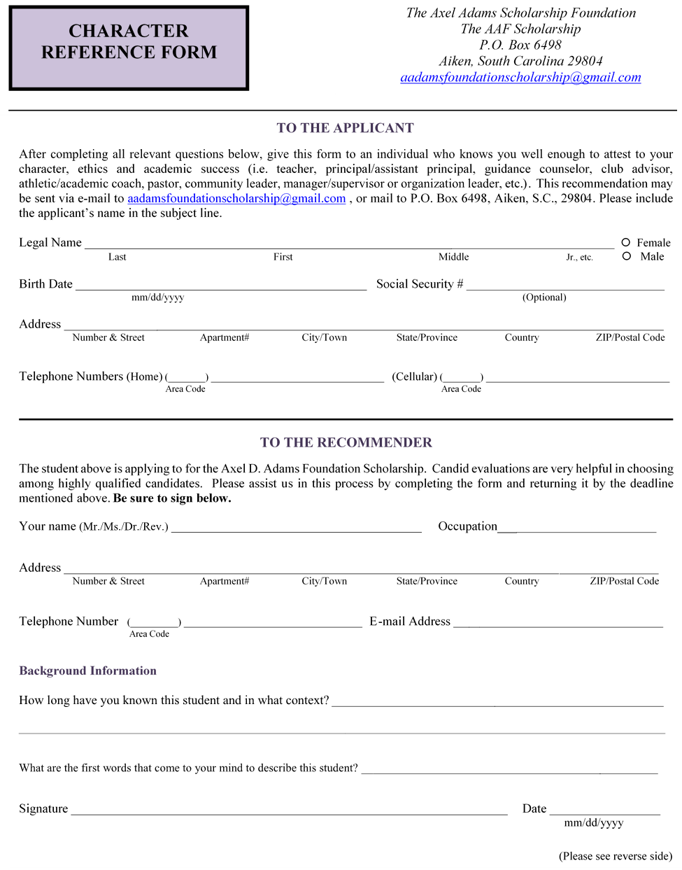
Ratings Compared to other students that you have known, how do you rate this student in terms of:

Below
No basis Average Average Above Average Excellent top 10% top 5% top1%

☐ | Intellectual promise | ☐ | ☐ | ☐ | ☐ | ☐ | ☐ | ☐
☐ | Creative, original thought | ☐ | ☐ | ☐ | ☐ | ☐ | ☐ | ☐
☐ | Respect accorded by others | ☐ | ☐ | ☐ | ☐ | ☐ | ☐ | ☐
☐ | Disciplined work habits | ☐ | ☐ | ☐ | ☐ | ☐ | ☐ | ☐
☐ | Maturity | ☐ | ☐ | ☐ | ☐ | ☐ | ☐ | ☐
☐ | Motivation | ☐ | ☐ | ☐ | ☐ | ☐ | ☐ | ☐
☐ | Leadership | ☐ | ☐ | ☐ | ☐ | ☐ | ☐ | ☐
☐ | Integrity | ☐ | ☐ | ☐ | ☐ | ☐ | ☐ | ☐
☐ | Reactions to setbacks | ☐ | ☐ | ☐ | ☐ | ☐ | ☐ | ☐
☐ | Concern for others | ☐ | ☐ | ☐ | ☐ | ☐ | ☐ | ☐
☐ | Self-confidence | ☐ | ☐ | ☐ | ☐ | ☐ | ☐ | ☐
☐ | Initiative, independence | ☐ | ☐ | ☐ | ☐ | ☐ | ☐ | ☐
☐ | OVERALL | ☐ | ☐ | ☐ | ☐ | ☐ | ☐ | ☐

Evaluation Please write what you think is important about this student, including personal characteristics, as demonstrated in interactions with this student. We welcome information that will help us to differentiate this student from others. (Feel free to attach an additional sheet or another recommendation you may have prepared on behalf of this student.)

